Narora Atomic Power Station
Narora Atomic Power Station (NAPS) is located in Narora, The plant is thus placed 68 km from the district headquarters in Bulandshahr.
Located in the small town of Narora (Uttar Pradesh), Bulandshahar District in Uttar Pradesh, India, the Narora Atomic Power Station (NAPS) services the northern power grid of India. .
As of 28 February 2003, NAPS reactors had achieved a cumulative generation of 28,366 million units (MUs) since they began commercial operations. Unit-1 registered 14,231 MUs of this total while Unit-2 accounted for 14,135 Mus

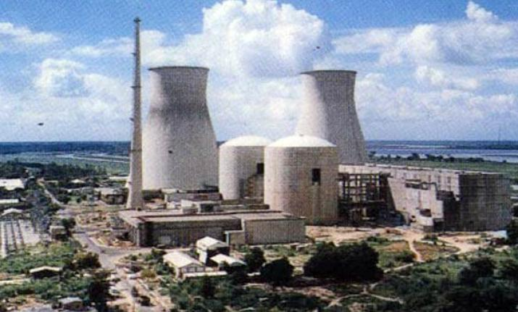

Reactors
The plant consists of two PHWRs, each a pressurized heavy-water reactor (PHWR) capable of producing 220 MW of electricity. The first of which (Unit-1) began commercial operations on 1 January 1991. Unit-2 followed on 1 July 1992. On 31 May 1993, a major fire occurred when the two steam turbine blades servicing Unit-1 malfunctioned. This, in addition to problems with the PHWR's cabling system, nearly led to a nuclear meltdown. Although NAPS was fully rehabilitated after the fire, a second incident hit Unit-2 in September 1999 when an air-locking inner door malfunctioned. The plant was immediately shut down and Unit-2 remained off duty for approximately one month. Although a minor tritium leak also occurred around this time period, by December 1999, the facility had been inspected by the Bureau of Indian Standards and its environmental management system had been certified. This certification was followed by the voluntary opening of NAPS to a World Association of Nuclear Operation (WANO) peer review board in early 2000. Later that year, NAPS became the first ISO-14001 certified atomic power station in Asia and also received the Golden Peacock Award from the World Environment Foundation for its efforts in environment preservation

Incidents
31 May 1993 after 28 months of operation two steam turbine blades in NAPS-1 malfunctioned causing a major fire. This in combination with problems in the reactor's cabling system nearly lead to a nuclear meltdown.

With India not being a signatory to the Treaty on the Non-Proliferation of Nuclear Weapons the reactors are not under IAEA safeguards. NAPS is not under International Atomic Energy Agency (IAEA) Safeguards.

Environmental Monitoring & Studies
At each of NPP sites, Environmental Survey Laboratories (ESL) are set up, which are operated by an independent organization viz. Health Physics Division of Bhabha Atomic Research Centre, Mumbai. At the existing NPPs sites, ESLs have been collecting and analysing radioactivity levels in the samples of various environmental matrices in the radius of 30 km from the plant site. Their reports conclude that the dose to population at the fence resulting from the existing NPPs in the country is about 1.5% of the authorized dose limit of AERB, which is a small fraction of the natural background radiation. The doses at further distances are still lower.

At NPP sites, environmental studies such as condenser cooling water discharge studies, thermal ecological studies, biodiversity conservation studies etc. are carried out for insuring compliance to environmental standards and environmental clearance stipulations from regulating agencies such as MoEF, AERB and State Pollution Control Board. These studies have demonstrated that the effect of thermal discharges from NPPs on marine ecology is confined to a small area and is reversible in nature.
Epidemiological Studies
NPCIL has carried out Health Sutrvey / Epidemiological Studies at all it operation site.

Effect of low dose ionizing radiation among the Employee at the Tarapur DAE Center: A Cross Sectional Study
Effect of low dose ionizing radiation among the Employee at the Rawatbhata DAE Center: A Cross Sectional Study
Effect of low dose ionizing radiation among the Employee at the Madras Atomic Power Station: A Cross Sectional Study
Effect of low dose ionizing radiation among the Employee at the Narora Atomic Power Station: A Cross Sectional Study
Dietary Health and biotic baseline survey around Kakrapar Atomic Power Station
Effect of low dose ionizing radiation among the Employee at the Kakrapar DAE Center: A Cross Sectional Study
Assessment of diet and Health status of Mandvi town with special reference to Kakrapar Atomic Power Station
Effect of low dose ionizing radiation among the Employee at the Kaiga Generating Station: A Cross Sectional Study
Epidemiological Survey – North Kanara District
Kudankulam Nuclear Power Project Clinical Survey Report
Epidemiological survey to evaluate Health status of the population around Kudankulam Atomic Power Project

Nuclear power in India
Nuclear power is the fifth-largest source of electricity in India after coal, gas, hydroelectricity and wind power. As of March 2018, India has 22 nuclear reactors in operation in 7 nuclear power plants, having a total installed capacity of 6,780 MW.^{[1][2]} Nuclear power produced a total of 35 TWh of electricity in 2017.^{[3]} 6 more reactors are under construction with a combined generation capacity of 4,300 MW.
In October 2010, India drew up a plan to reach a nuclear power capacity of 63 GW in 2032,^{[4]} but after the 2011 Fukushima nuclear disaster in Japan people around proposed Indian nuclear power plant sites have launched protests, raising questions about atomic energy as a clean and safe alternative to fossil fuels.^{[5]} There have been mass protests against the French-backed 9,900 MW Jaitapur Nuclear Power Project in Maharashtra and the Russian-backed 2,000 MW Kudankulam Nuclear Power Plant in Tamil Nadu. The state government of West Bengal state has also refused permission to a proposed 6,000 MW facility near the town of Haripur that intended to host six Russian reactors. A Public Interest Litigation (PIL) has also been filed against the government’s civil nuclear programme at the Supreme Court.
The capacity factor of Indian reactors was at 79% in the year 2011-12 compared to 71% in 2010-11. Nine out of twenty Indian reactors recorded 97% capacity factor during 2011-12. With the imported uranium from France, the 220 MW Kakrapar 2 PHWR reactors recorded 99% capacity factor during 2011-12. The Availability factor for the year 2011-12 was at 89%.
India has been making advances in the field of thorium-based fuels, working to design and develop a prototype for an atomic reactor using thorium and low-enriched uranium, a key part of India's three stage nuclear power programme. The country has also recently re-initiated its involvement in the LENR research activities, in addition to supporting work done in the fusion power area through the ITER initiative.

